**Project Report on**

**Pigmy Deposit System**

**Submitted in partial fulfilment of requirement for the degree of**

**MASTER OF COMPUTER APPLICATIONS**

**OF   
UNIVERSITY OF MUMBAI**

**Submitted by**

**Name :Nilesh Kadam**

**Roll no:13**

**M.C.A (2014-2017)**

**Department of Computer Applications**

**SIES College of Management Studies**

**Nerul, Navi Mumbai**

**ACKNOWLEDGEMENT**

I am glad to inform you about the completion of our system **“Pigmy Deposit System”** which is in Java,PHP and MYSQL.

Firstly I would like to thank our Project guide, **MR. Anup Palsokar** for allowing us to go ahead with this project and providing us their valuable guidance and support.

Last but not the least, I would like to thank **my parents** and **my colleagues** whose good wishes , strong support for providing me the morale and financial support. I have put in our best effort to make this project valuable, and its easy handling will make it successful.p

And lastly I would like to thank all **teaching** and **non-teaching** staff members who directly or indirectly helped me to make this project a success.

Nilesh Kadam

**INDEX**

|  |  |  |
| --- | --- | --- |
| **Sr No** | **Name Of Topics** | **Page Number** |
| 1. | **Introduction**  1.1 Admin Module  1.2 Staff Module  1.3 Agent Module  1.4 Customer Module | 3-4 |
| 2. | Background | 5 |
| 3. | Analysis and design  3.1Requirements gathering  3.2Choice of technology  3.3Overall system structure  3.4Diagrams | 6-10 |
| 4  . | Implementation  4.1Admin Module  4.2Staff Module  4.3Agent Module  4.4Customer Module | 11-13 |
| 5. | Testing  5.1Website testing cases  5.2All application testing cases | 14-15 |
| 6. | Conclusion , evaluation and further work | 16-17 |
| 7. | Appendices | 18-29 |
| 8. | Bilbiography | 30 |

**1. Introduction**

**Pigmy Deposit Scheme** is a monetary deposit scheme introduced by [Syndicate Bank](https://en.wikipedia.org/wiki/Syndicate_Bank), [India](https://en.wikipedia.org/wiki/India). Money can be deposited into an account on daily basis. The amount may be as small as [Rupees](https://en.wikipedia.org/wiki/Rupees) five. It can be called a recurring deposit scheme, as the money is deposited almost daily. The unique characteristic of this scheme is that a bank agent collects the money daily, from the account holder's doorstep. Through this scheme we will be able to develop the saving habit in customers and will enable them to deposit money on daily basis from their home itself to fulfill their financial requirements for better future and prosperity.

Pigmy Deposit System is basically a computerized solution for Pigmy Deposit Scheme process carried out in banks. This provides two software and one website . First Software for Bank, second software for Agents and website for Customer to see daily transaction.

The Project basically consist of four modules:

**1.1 Admin module**:

A Java application through which Admin can:

1) Register new Admin

2) Register new staff

3) View all staff and admin details

4) Update staff and admin details

**1.2 Staff module**:

A Java application through which Staff can:

1) Open new customer account

2) Open new Agent account

3) View daily base transaction

4) Verify customer account register by agent

5) Cross verify the customer amount and deposit in customer account

6) View, update, delete customer Account

7) View, update, delete agent Account

8) Approve loan

9) View Day wise transaction

10) View Report and print report

**1.3 Agent module**:

A Java application through which agent can:

1) Open new customer account

2) Enter daily report

4) View ,update, delete customer Account

5) View Day wise transaction

6) View Report and print report

**1.4 Customer module**:

Is an HTML, PHP website by using which a customer can :

1) View account summary

2) View account details

3) Account Statement

3) Change password

4) Change pin number

**2.Background**

In the **Pigmy Deposit Scheme** the bank agent collects the money daily ,from the account holder’s doorstep. The problem is that how any account holder would know that the agent has deposit his money in the bank or not. So this website shows account summary, account details. This website connects to the bank database.

Agent collects the money daily from customer and enter amount in an agent application. Next day agent goes into bank and deposits money .The bank staff verifies and deposits into customers account. When the amount is deposited into customers account then customer sees this through website. If any help required customer can call bank customer care number.

The bank gives 3 % Commission on monthly collection to Agent. This Commission is deposited into agent’s saving account . Bank gives 2% interest to customer upto 1 year. The loan can be availed up to maximum 60% of the balance and interest of loan will be 4%. This calculation is complicated and also storing all customer and agent details manually is complicated to manage. So this application helps agent and bank staff manage all details and access all details easily.

In the next few sections we see the actual implementation of the system design issues and testing.

**3.Analysis and design**

In this phase we analyze various aspects of the system ,the requirement of the user

and after gathering all this information finding out the optimized way for implementing the system which meets the user requirements.

**3.1 Requirements gathering**

In this phase the basic requirement of the project is gathered. At First the problem is analyzed and then information is gathered .

**3.2 Choice of the technology**

Second concern was which technology to use for the project. For this project JAVA technology is used for the agent and bank application , HTML and PHP language is used for the website development and MYSQL for database storing the records. Lastly all these technologies are open source as per the university requirement

**3.3 Overall system structure**

The overall system structure is divided into four parts:

1. The admin module

Admin module is standalone JAVA application for the Admin in the

bank. The Admin logs in to the system, he can check the information of the bank staff , create new admin, create new staff member.

1. The Staff module

Staff module is standalone JAVA application for the staff in the bank. the staff logs into system and view all customer and agent list, create new accounts, update information.

1. The Agent module

Agent module is standalone JAVA application for the agents . the agent logs into system and view all customer list, create new accounts, update information.

1. The customer module

Customer module is a dynamic website for customer. The customer logs into website and views his account summary.

**3.4 Diagrams**

Use Case

:

ER – diagram

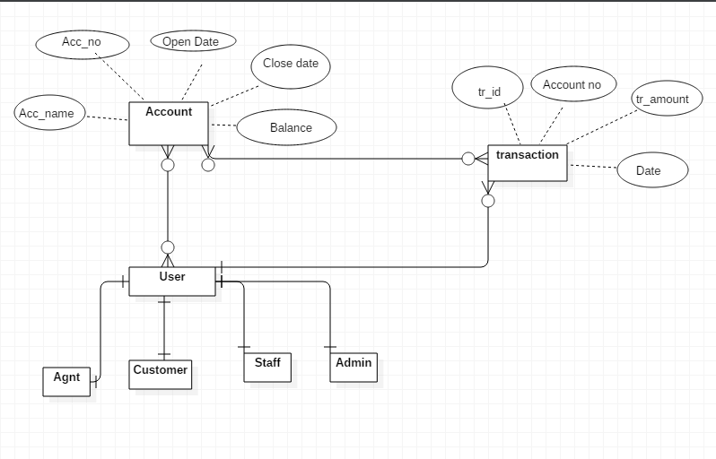

Class Diagram:

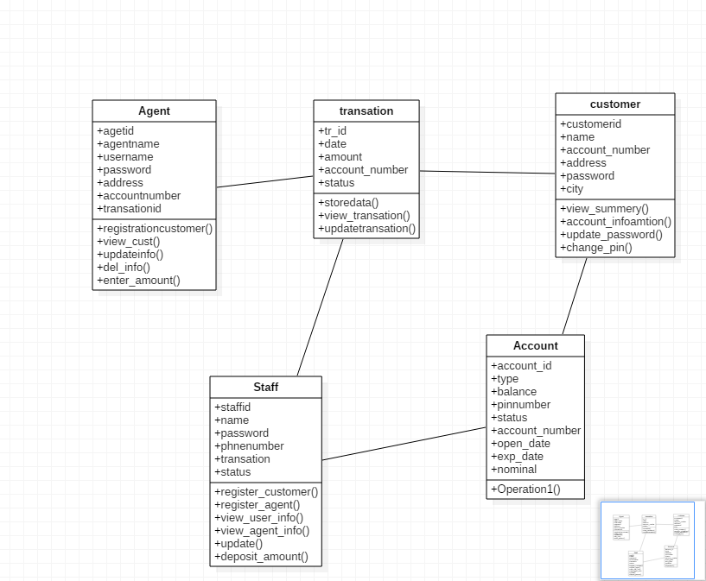

Activity diagram:

For Customer website

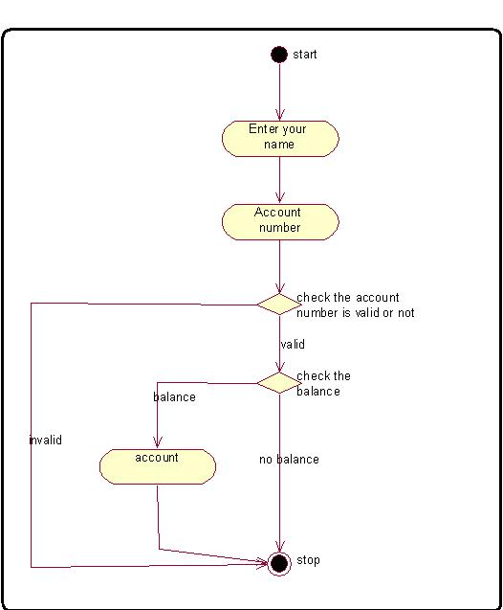

**4. Implementation**

**4.1 Admin module**:

A Java application through which college can:

**1) Create a new login for staff**

The admin can register new staff and give username and password to staff. This stores all information about staff into the database. The registration form contains personal information, address and account details.

**2)Create a new Admin :**

The admin can register new admin and give username and password to staff. This stores all information about admin into the database. The registration form contain personal information, address and account details.

**3) View all details of customer and admin**

Admin can view all details about customer and admin.

**4)Update or delete customer/admin details**

Admin can update all details of admin or customer.

**4.2 Staff module**:

A Java application through which staff can:

**1)Create a new account for agent and customer**

The staff can register new agent/customer and give username and password to customer/agent. This stores all information about agent/customer into the database. The registration form contains personal information, address and account details. When the new customer is registered all documents should be submitted by agent and opening amount is deposited .

**2) Deposit money into customer account**

Staff deposits amount into customer’s account and this form shows that particular days collection of that agent. Staff selects the agent account number and selects the date .After selecting staff clicks on search button then it shows all customer record

**3) Update/delete today’s amount entry**

Staff can update/delete today’s amount entry which are made by agent using agent application.

**4)View ,Update,** **delete Agent account**

Staff can update, delete Agent account. In this staff can search agent by his name,account number and all this information is show in JTable .Staff selects agent in jtable and updates agent information.

**5)View ,Update,** **delete Customer account**

Staff can update, delete Customer account. In this staff can search customer by his name,account number and all this information is show in JTable. Staff selects agent in jtable and updates customer information.

**6)** **Verify Customer account**

Staff checks all customer documents and verifies all details which are filled by agent using his agent application .If documents are not valid he can also delete the registered account.or if any changes are required then its reflected in the system.

**7)** **Loan**

Suppose customer needs loan then he can apply for loan. Loan can be availed up to maximum 60% of the balance and interest of loan will be 4 %.

**8)** **View Transaction**

Staff can see all list of transaction. Staff can see all transaction date wise.

**9)** **Print report**

Staff can print report of customer and agent.

**4.3 Agent module**:

A Java application through which staff can:

**1)Create a new account for customer**

The agent can register new customer and give username and password to customer. This stores all information about customer into the database. The registration form contains personal information, address and account details. When the new customer is registered all documents should be submitted to agent and opening amount should be deposited.

**2) Enter money into customer account**

Agent makes Enters money into customer account. Agent logs into his account and enters that days collected amount .

**3)View ,Update,** **delete Customer account**

Agent can view, update, delete customer account. In this agent can search customer by his name, account number. All information is show in JTable. Agent selects customer in jtable and updates customer information.

**4)** **Print report**

Agent can print report of customer.

**4.4 Customer module**:

A Java application through which customer can:

**1)View Account Summary:**

Customer logs into website and can check his current account balance. user can also checks the all transaction .

**2) View Account Details**

Customer can see all his details and user can see his username ,pin number ,address are shown in this portal.

**3) Change password**

Customer can change his password using this website.

**5)** **Change Pin**

Customer can change his Account security pin number using this website.

**5.Testing:**

**5.1 Test Cases for website**

**1)Login to the Website:**

**Case 1:** If the account number or password is not match?

**Valid result:** If the Account and password are found in database then message is displayed that the user is successfully logged in the system.

**Invalid result:** If Account and password not exist then a message is display you are not the registered user please register first.

**Case 2:** If the pin number is not match?

**Valid result:** If the pin are found in database then message is displayed that the user is successfully logged in the system.

**Invalid result:** If pin not exist then a message is display you are not the registered user please register first.

**Case 3:** If Password field is empty when changing the password?

**Valid result:** If the Password field is not Empty and password and confirm password is match then customer pass is change

**Invalid result:** If Password field is empty t then a message is display please fill password filed.

**Case 4:** If pin field is empty when changing the pin?

**Valid result:** If the pin field is not Empty and pin and confirm pin is match then customer pin is change

**Invalid result:** If pin field is empty t then a message is display please fill pin filed.

**5.2 Test case for application**

**1)Login to the system:**

**Case:** If the Account or password is exiting in the system?

**Valid result:**If the username and password are found in database then message is displayed that the user is successfully logged in the system.

**Invalid result:**If username and password not exist then a message is display you are not the registered user please register first.

**6.Conclusion Evaluation and further work**

**6.1Conclusion:**

The purpose of the system is automate the **Pigmy Deposit Scheme** . Earlier there was no such system where agent enter report and this report verify by staff and it reflect on customer account.

The main aim of the project is to overcome the drawbacks of the manual system. Because of many Customer do not get the information about his account So they do not know what is interest on his balance. Now by using the website Customer can access his account information from anywhere in country, this is an advantage. Also the system Verify account,calculate automatic loan amount, calculate interest on his saving adds much more clarity in process and also overcomes the human error. Also this system provides a more convenient way to store the Customer and Agent information and also able to fetch it whenever needed. So this system provides a more efficient way to handle the admission process in the Bank.

**6.2Further work:**

The system can be further enhanced which can be implemented in future so as to give better performance:

1)System send messages to customer /Agent.

2)Develop android application.

**7.Appendices**

**7.1. System Manual**

* **Hardware Requirements:**

Computer :

Processor Pentium 4 or above

RAM 2GB or above

HDD 40GB or above

* **Software Requirements:**
* Agent,Staff,Admin Module:
* Front End:JAVA
* Back End:MYSQL
* Customer Website:
  + - Front End: HTML , PHP , CSS , Javascript
    - Back End: MYSQL

**7.2 User Manual**

**Screen Shots**

Login :

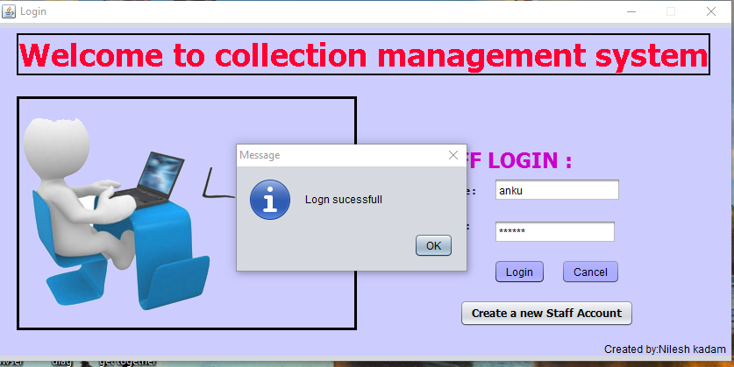

Main MDI Form:

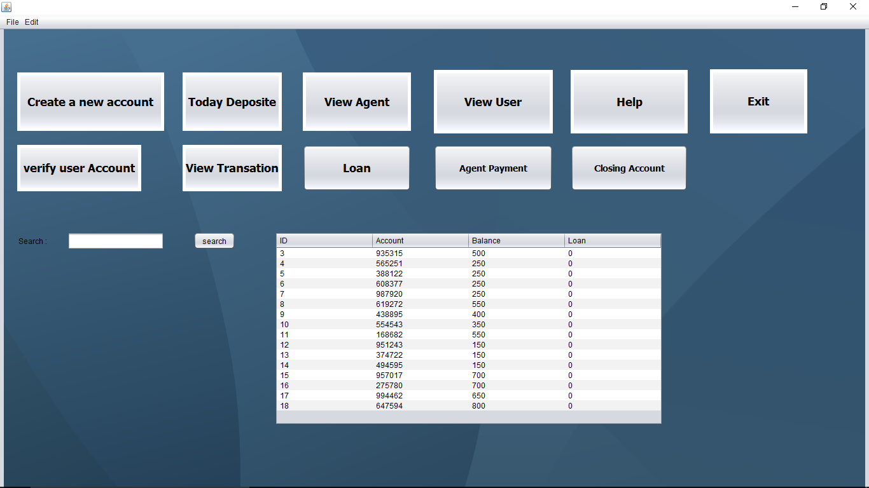

Agent Registration:

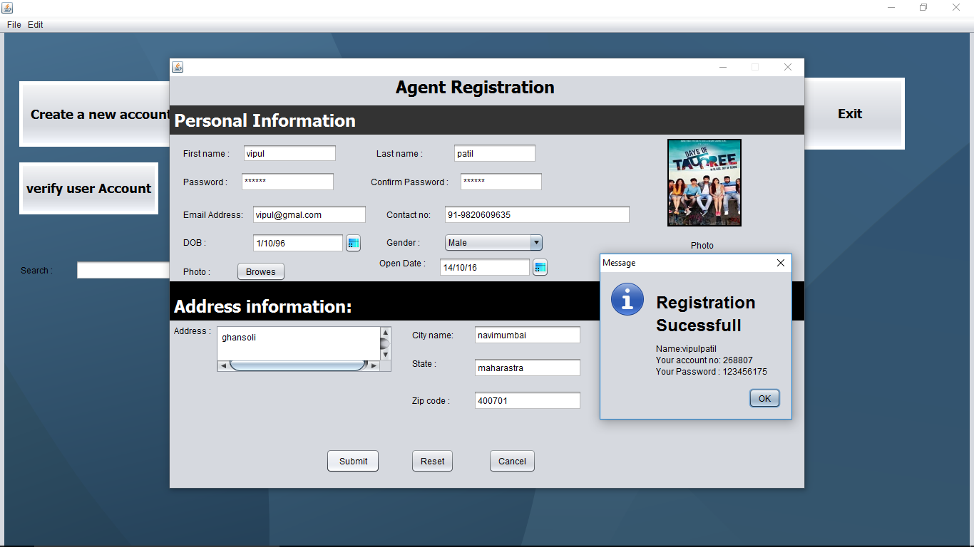

List of all agents

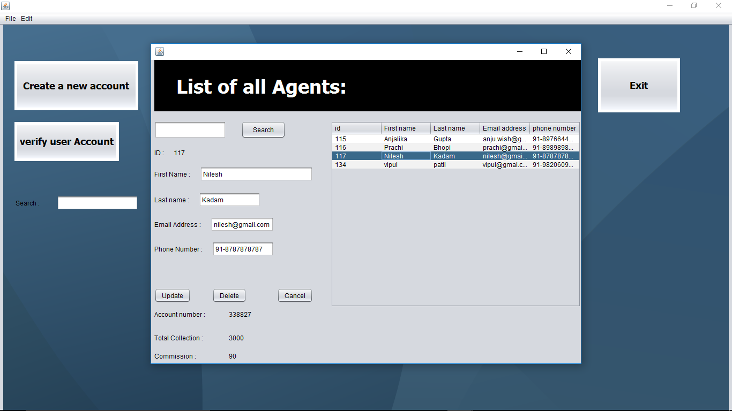

List of all Customer

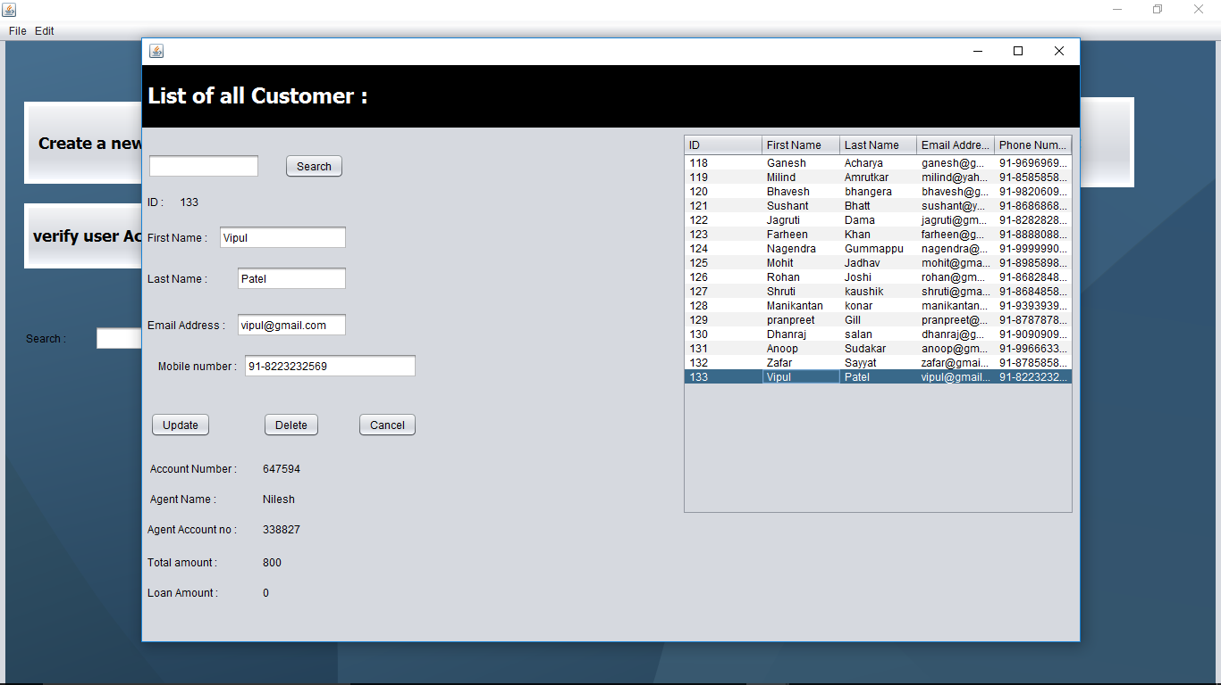

Report

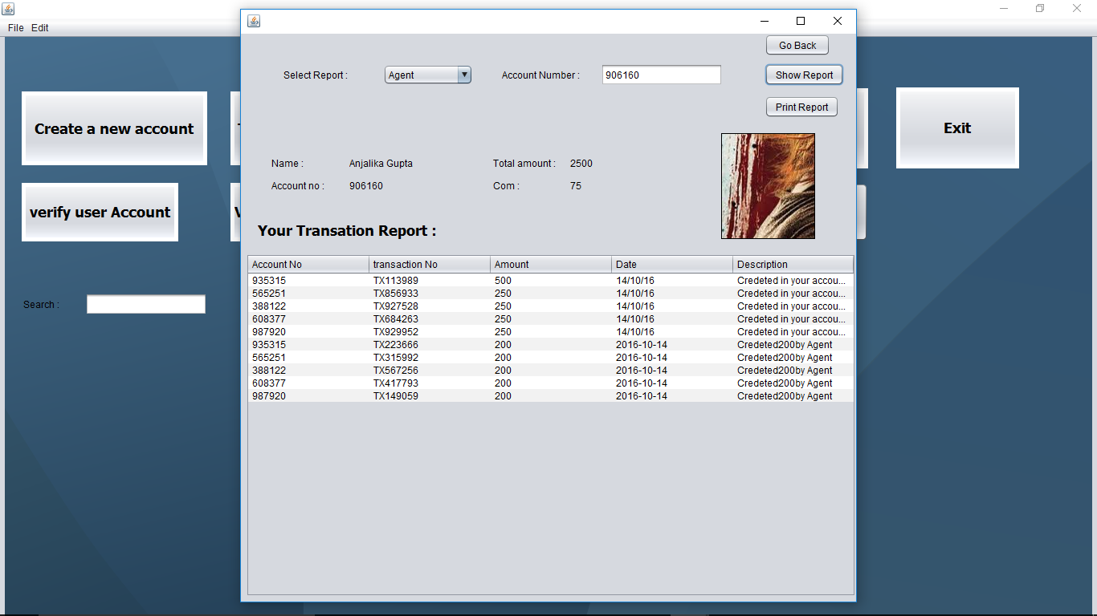

Customer Reports

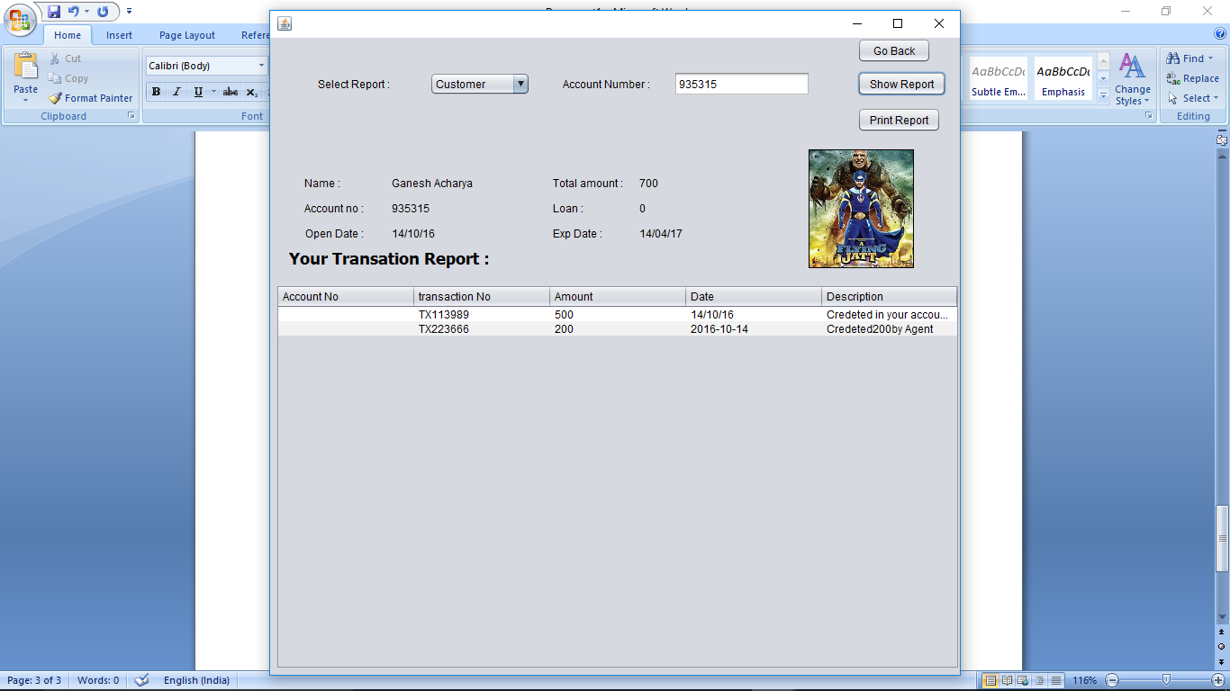

Loan Amount

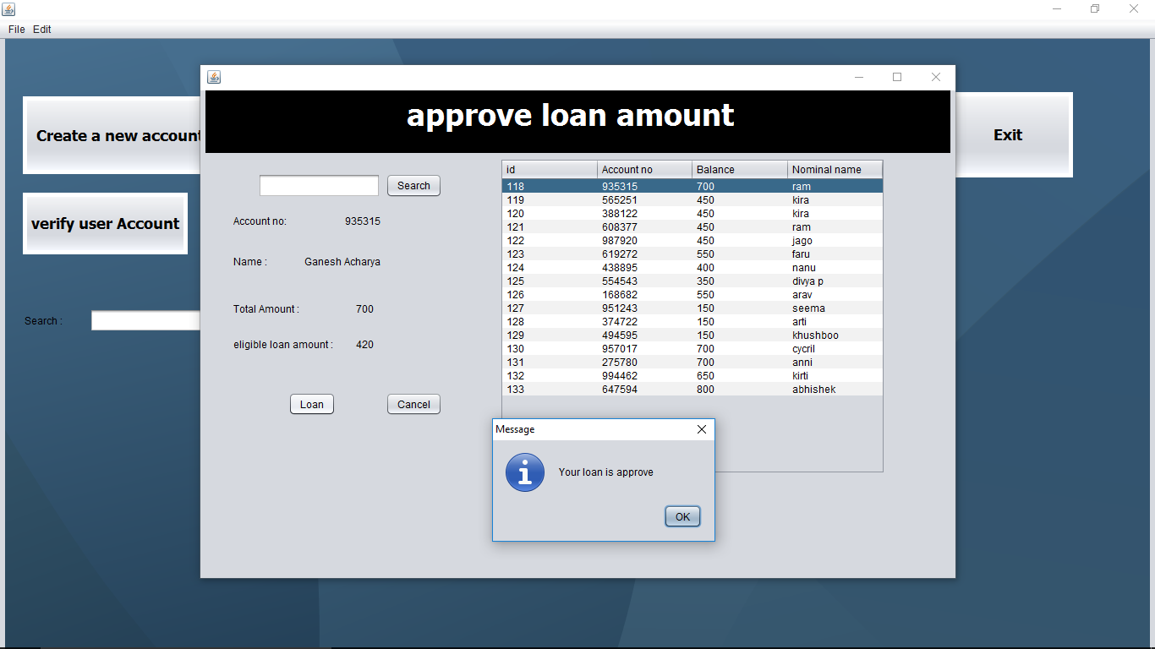

Close Account:

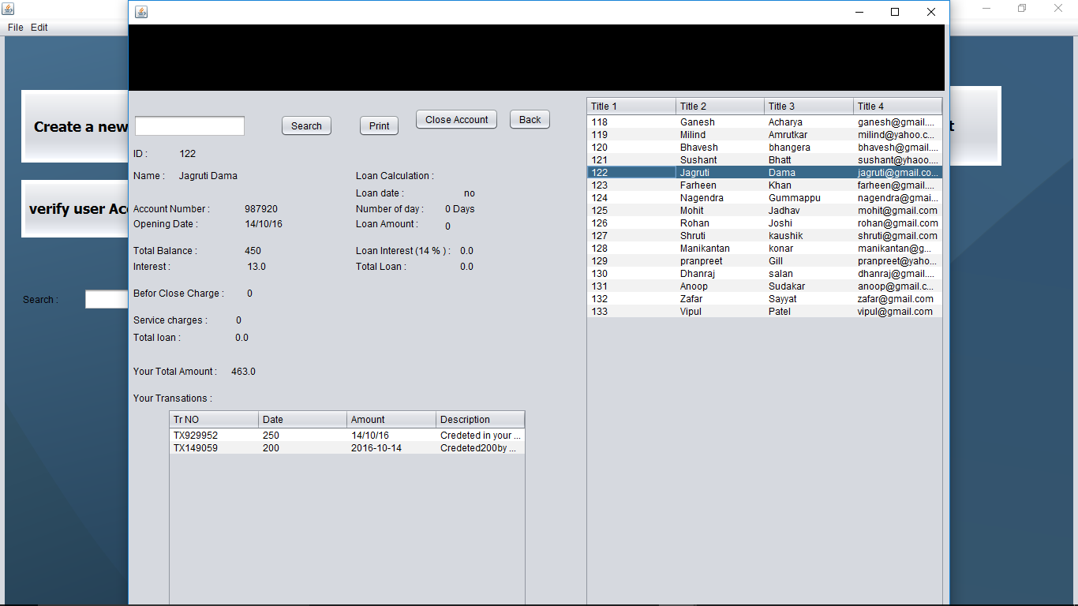

Agent Payment:

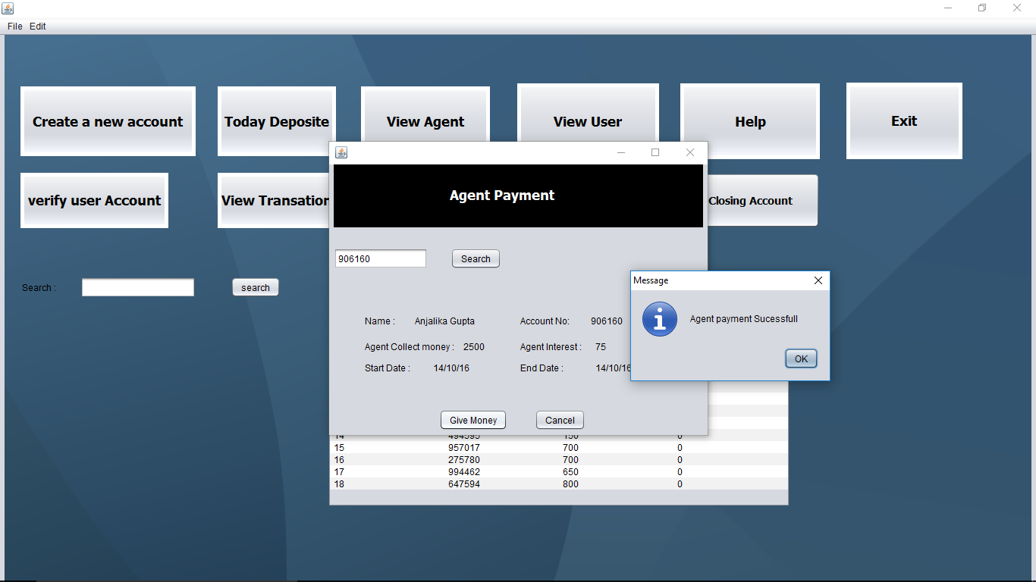

**Agent Software:**

Agent Panel

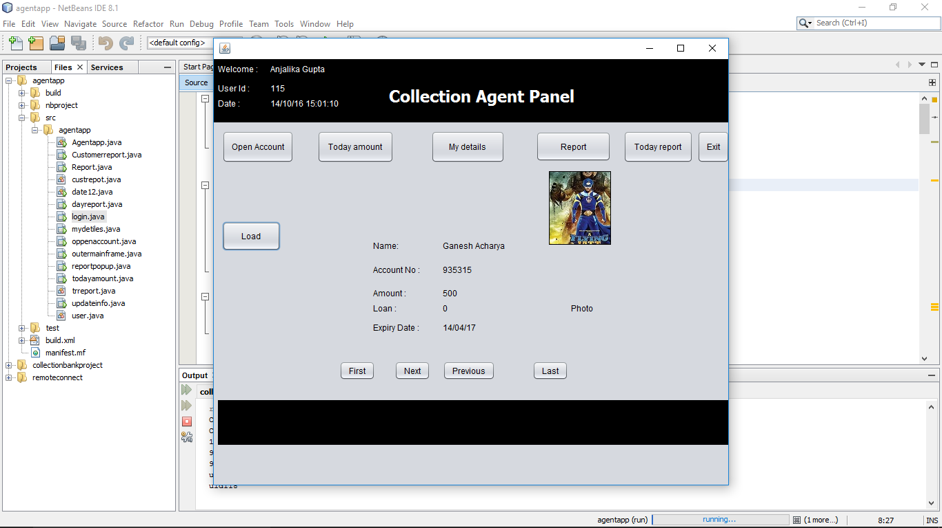

Today Collection

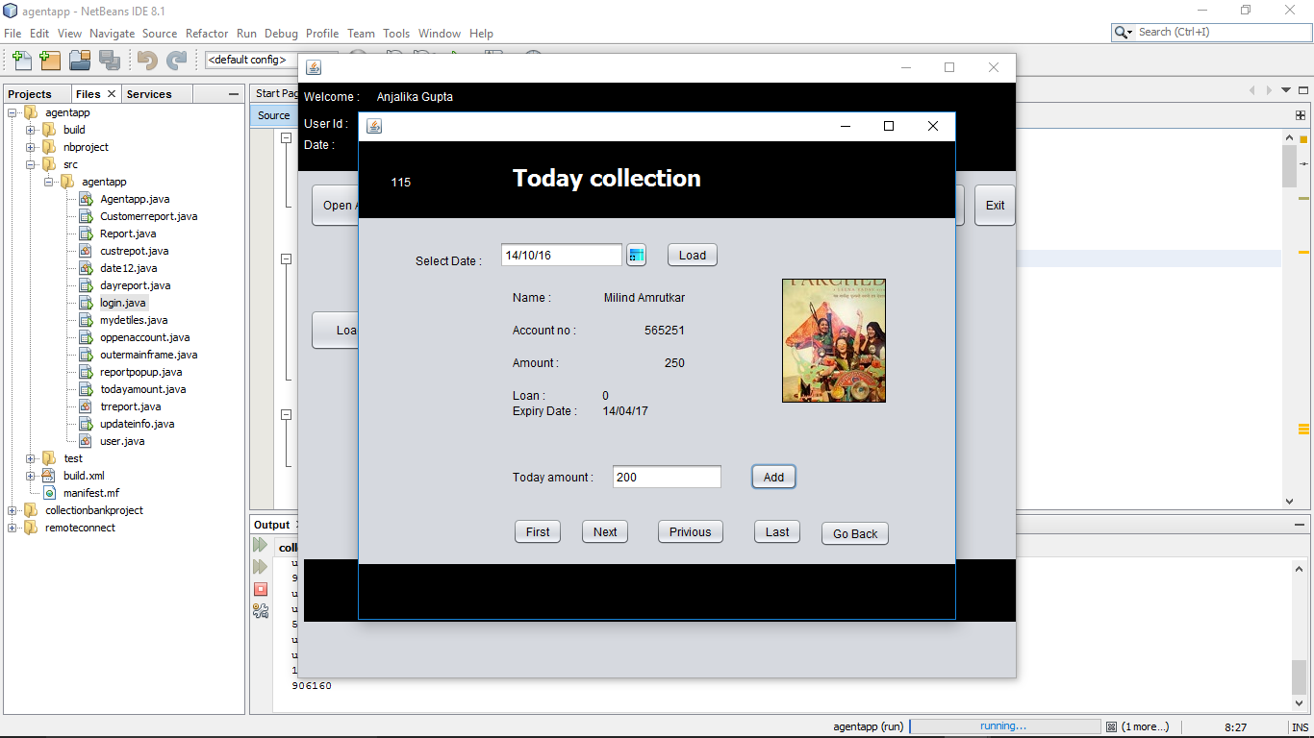

Today money Report

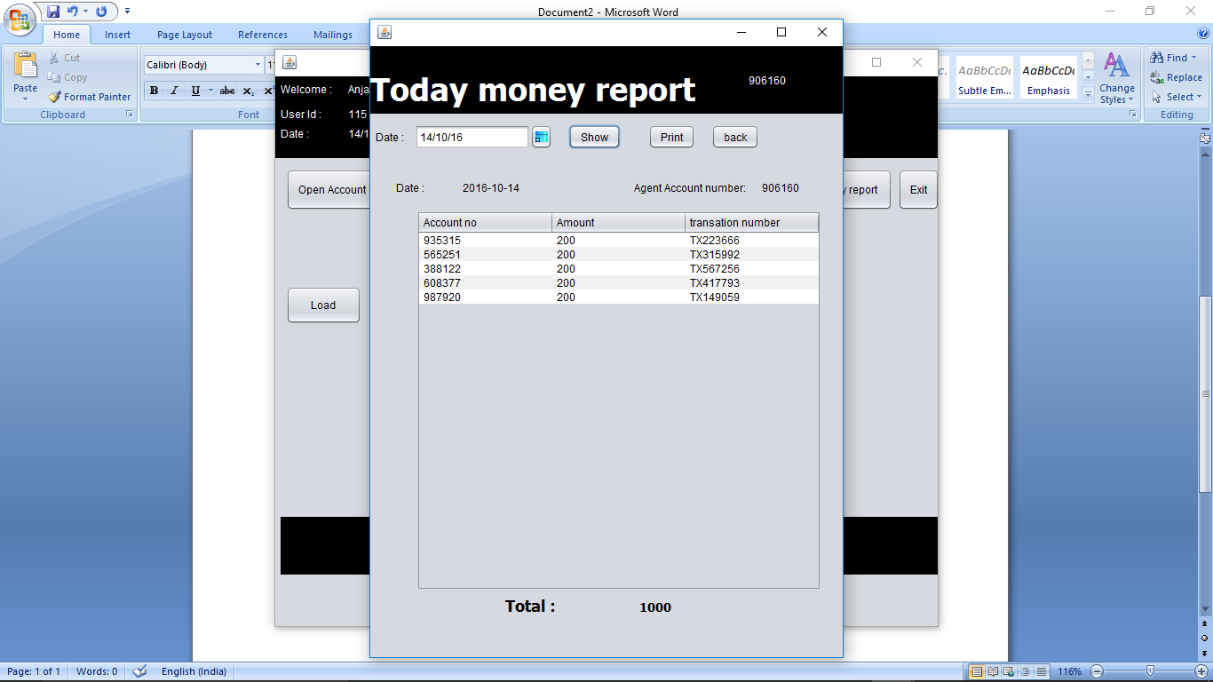

Deposit amount:

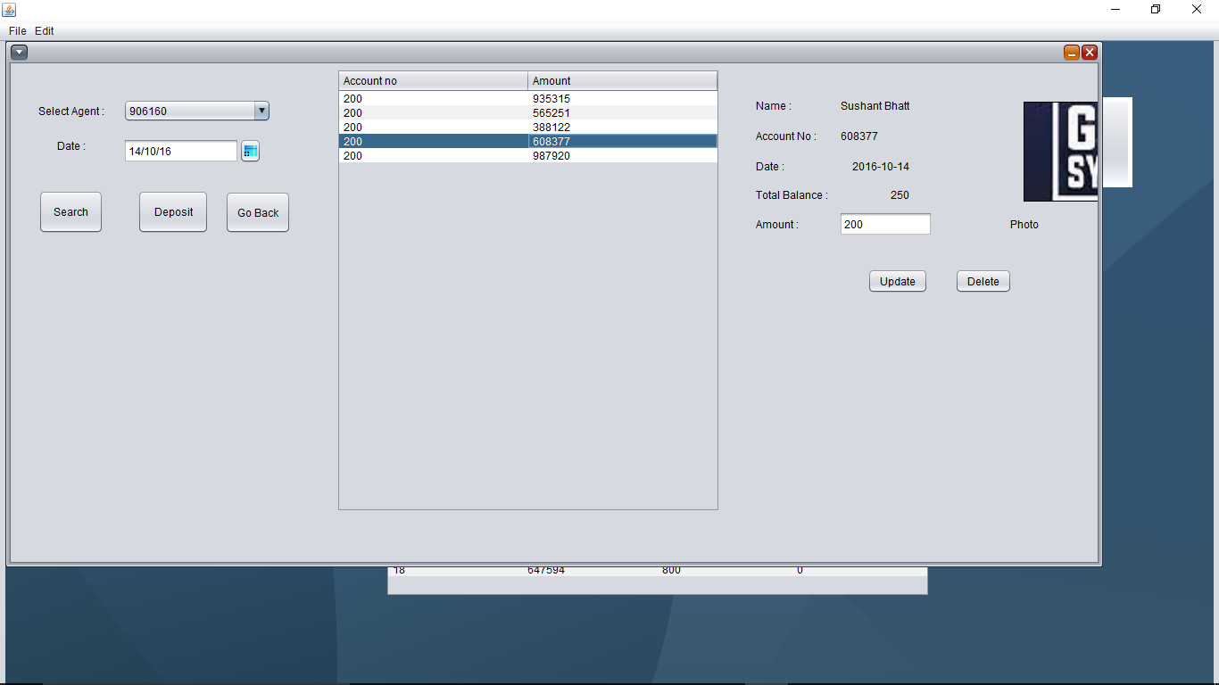

Report

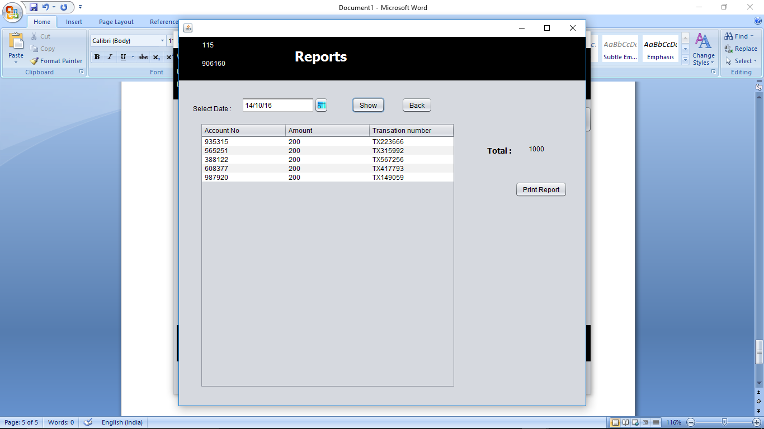

Customer Report

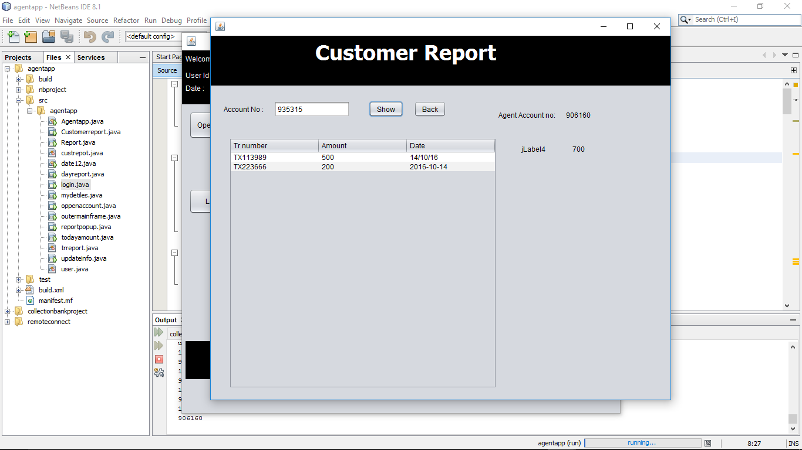

**Website :**

**Login:**

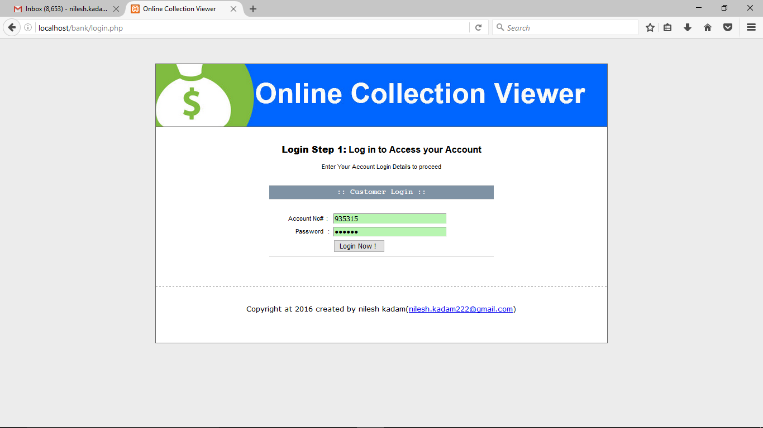

Enter pin:

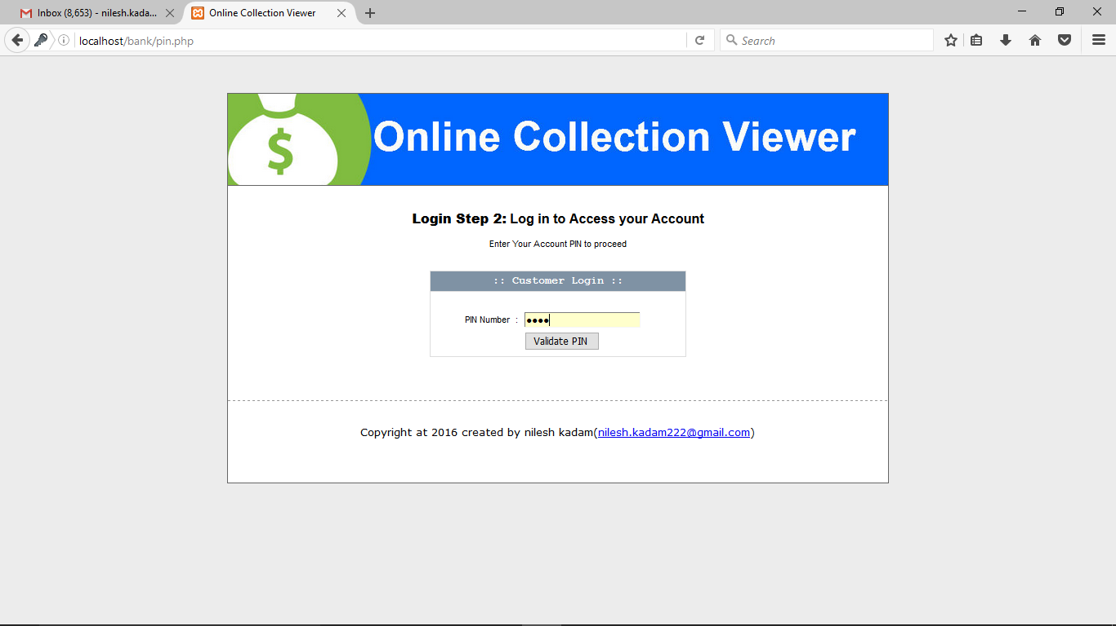

View Account summery

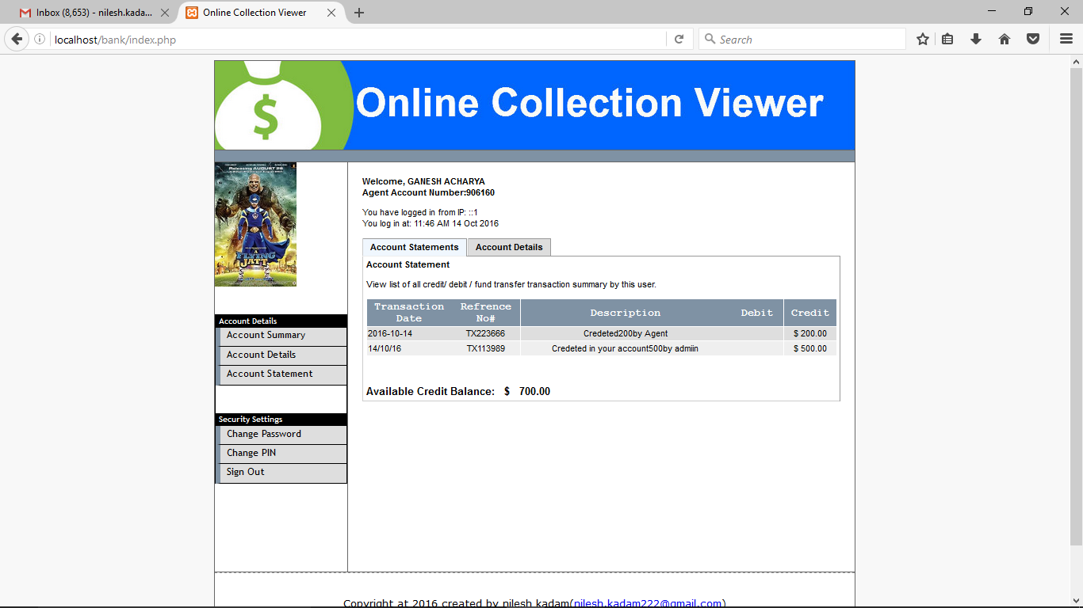

View Account Details

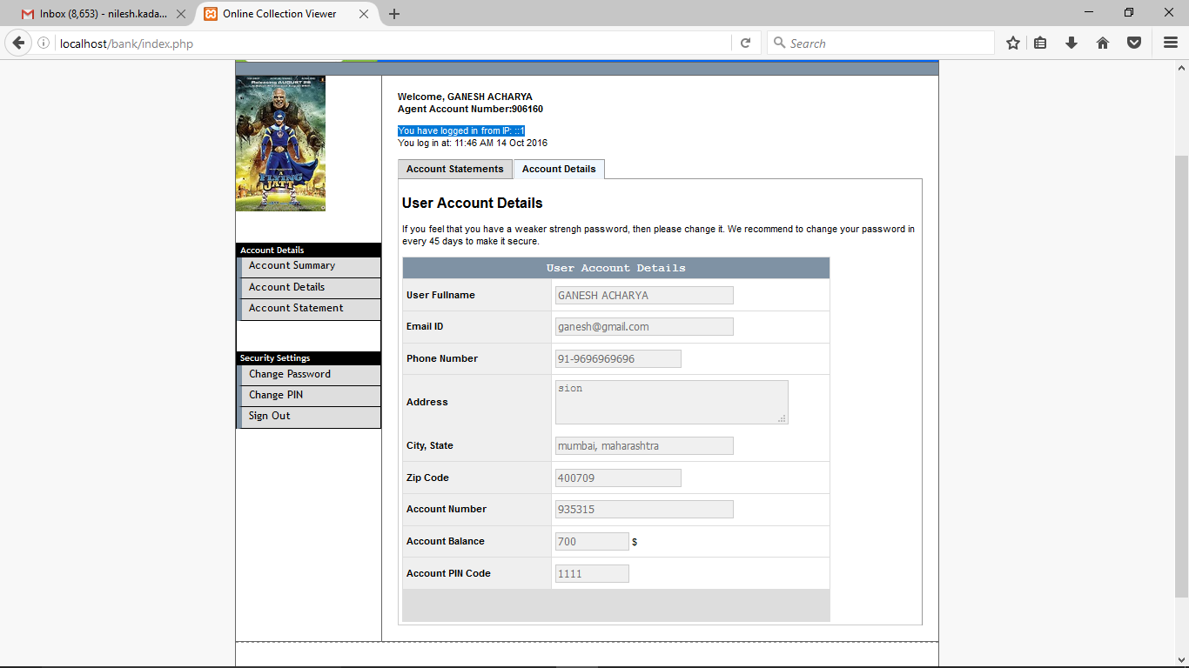

Change Password

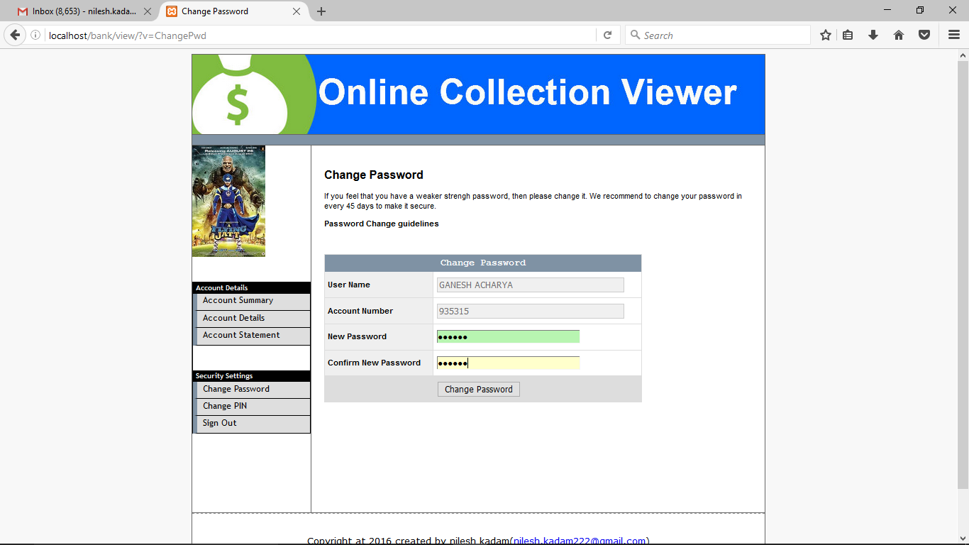

Change Pin

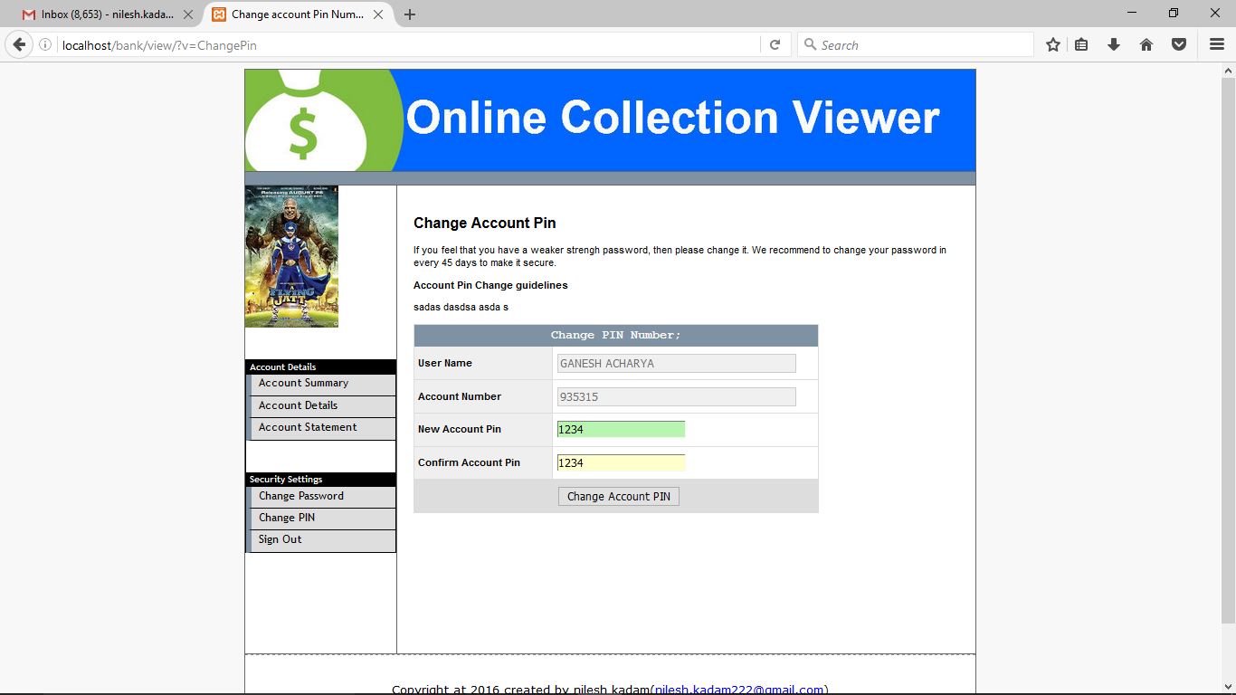

**8.Bibliography:**

**1)PHP Complete Reference**

**2)Murarch PHP and MYSQL**

**3)JAVA The Complete Reference**

**4)Programming with JAVA by E Balaguruswamy**

**5)Beginning MYSQL**

**6)www.w3schools.com**

**7)www.tutorialspoint.com**

**8)www.stackoverflow.com**